**AMAZON WEB SERVICES**

AWS using CLI:

* Download CLI in Linux system using ***curl "https://awscli.amazonaws.com/awscli-exe-linux-x86_64.zip" -o "awscliv2.zip”****.*
* Unzip the package using ***unzip awscliv2.zip****.*
* Install the package using ***sudo ./aws/install****.*
* Check using aws --version.
* Create an access key for AWS CLI.
* Download the CSV file and save it, it has your Access Key ID and Secret Access Key.
* Now go to console and type “aws configure” to configure your aws using CLI.
* The cmd prompt will ask for Access Key ID, Secret Access Key, Default region and Default Output format. Provide the necessary details; ap-south-1 for default region as Mumbai.
* You can also save your Access Key ID and Secret Access Key in Environment Variable which is supposed to be a good practise in terms of security vulnerability.
  + export AWS_ACCESS_KEY_ID=*******
  + Visit AWS CLI documentation for better understanding.
* To launch an EC2 instance, we need a key-pair. Use the following command to create a key-pair in AWS CLI
  + *aws ec2 create-key-pair --key-name MyKeyPair --query 'KeyMaterial' --output text > MyKeyPair.pem*
  + Visit AWS CLI documentation for better understanding.
* To delete a key-pair use
  + *aws ec2 delete-key-pair --key-name MyKeyPair*
* To view a specific key-pair
  + *aws ec2 describe-key-pairs --key-name MyKeyPair*
* To view all the key-pairs
  + *aws ec2 describe-key-pairs*
* To create a new instance
  + *aws ec2 run-instances --image-id ami-xxxxxxxx --count 1 --instance-type t2.micro --key-name MyKeyPair --security-group-ids sg-903004f8 --subnet-id subnet-6e7f829e*
    - *--image-id ->* Amazon Machine ID designated to OS
    - *--count ->* No. of instances
    - *--instance-type ->* Type of instance you want to create
    - *--key-name ->* Key that you are connecting with
    - *--security-group ->* default if there’s none
    - *--subnet-id ->*
* To describe all the instances
  + aws ec2 describe-instances
* To give a name tag to our instance
  + *aws ec2 create-tags --resources i-06f11bdc677d51a59 --tags Key=Name,Value=MyNissanInstance*
    - *--resources ->* Instance ID of your instance
* To terminate an ec2 instance
  + *aws ec2 terminate-instances --instance-ids i-06f11bdc677d51a59*
* To stop an instance
  + *aws ec2 stop-instances --instance-ids i-06f11bdc677d51a59*
* To reconnect/start an instance
  + *aws ec2 start-instances --instance-ids i-06f11bdc677d51a59*
* To connect to your instance using AWS CLI
  + Change the inbound and outbound rules of the instance and add

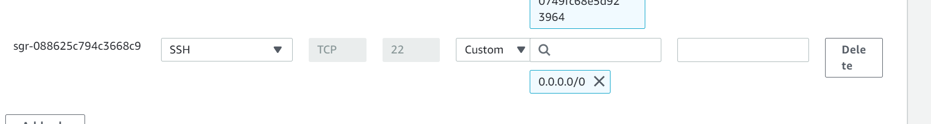

* + Use the following command to connect to the instance
    - *ssh -i Nissan885KeyPair.pem* [*ec2-user@65.2.30.146*](mailto:ec2-user@65.2.30.146)
      * *Nissan885KeyPair.pem ->* is the key-pair used to connect to the instance
      * *ec2-user ->* User name of the instance
      * *65.2.30.146 ->* Public IPv4 address o the instance

***\*\**You must be on the same directory which has the key-pair file before connecting to the instance.\*\***

**AWS ECS (Elastic Container Service)**

ECS: ECS is managed container orchestration

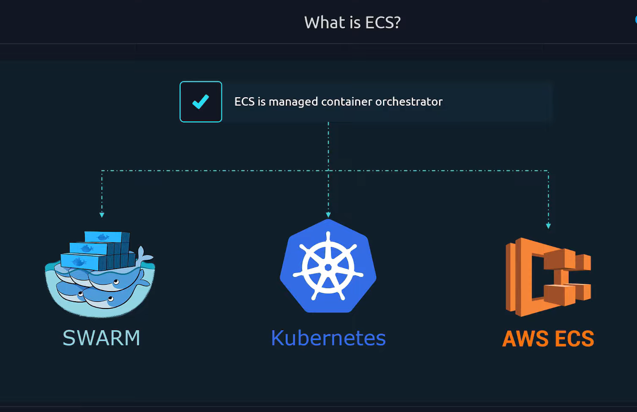

Why Orchestration?

* Manage lifecycle of containers (create/restart/destroy)
* Deploy & load-balance application across multiple servers
* Auto-scaling to handle variance in traffic
* Rolling out changes to application

Why ECS?

1. Even if we deploy 2 or 3 docker containers on different servers. they won’t be aware of each other, as they will simply be a copy running on a server.
2. Load balancing won’t be possible as they are separate containers running on separate servers without aware of each other.
3. ECS helps us managing these issues

ECS

* It stands for *Elastic Container Service*
* It has 2 types
  1. EC2
  2. Fargate
* ECS works only with a container. It can only create or destroy a container.
* Cluster: Cluster is a group of resources, could be EC2 instances on which the containers are deployed by the ECS.

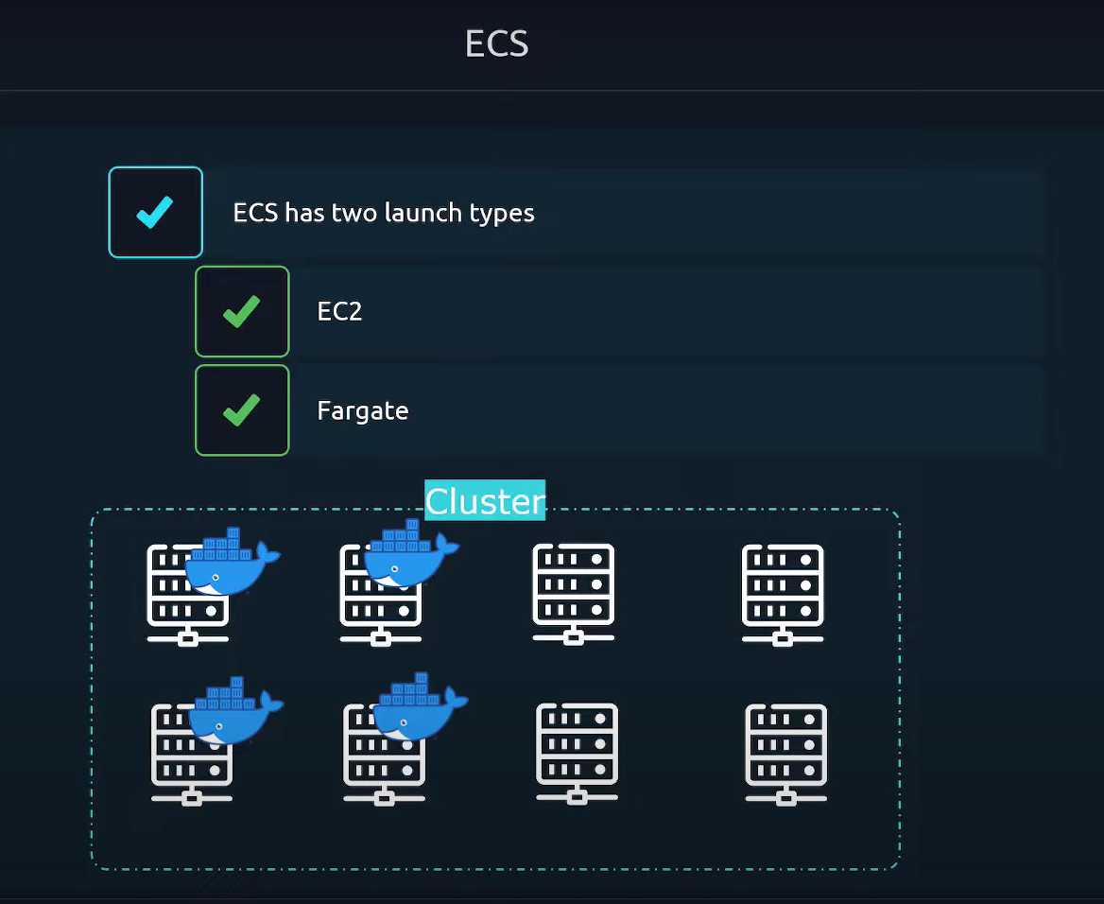

* ECS Types
  1. EC2
     + Instances must be managed by our own.
     + Have full control over the infrastructure.
     + Must install an ECS Agent on each EC2 instance.
     + ECS Agent: These agents are required for the *ECS Control Panel* to communicate with the EC2 instance.

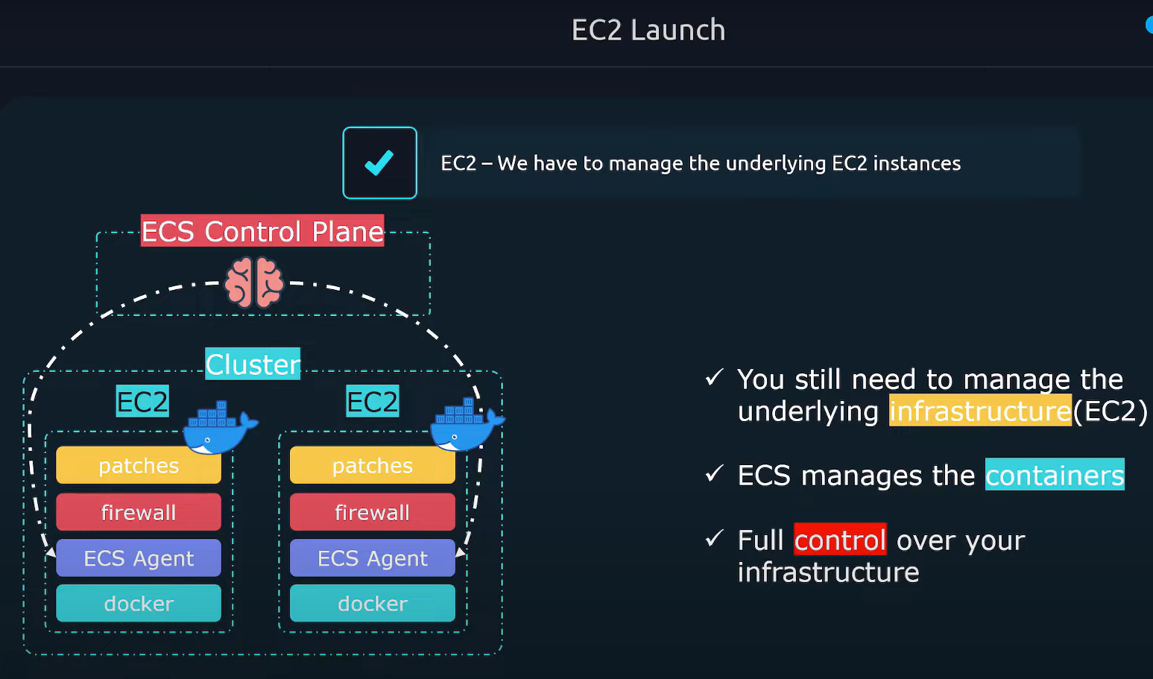

* 1. Fargate
     + AWS manages the underlying infrastructure.
     + Fargate is a serverless architecture.
     + Fargate will create the servers on demand.
     + After Fargate creates the servers, ECS will deploy the containers on the servers.
     + We don’t need to maintain the infrastructure.
     + Fargate will scale the servers on demand.
* **ECS Task Definition:** 
  1. It is a blueprint which describes how the containers should launch.
  2. How much CPU/Memory.
  3. Image/Ports/Volumes.
  4. It basically contains all the specifications that you’ll see in a docker compose file.

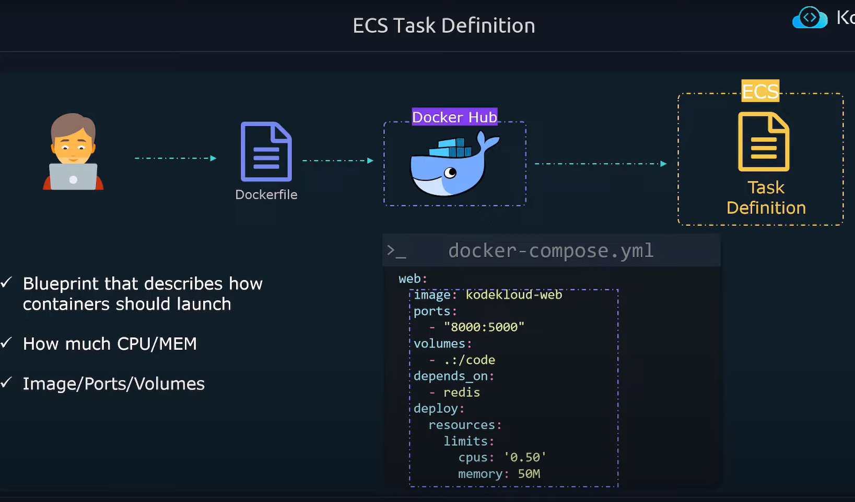

* **Task:** It’s an instance of a *Task Definition.*

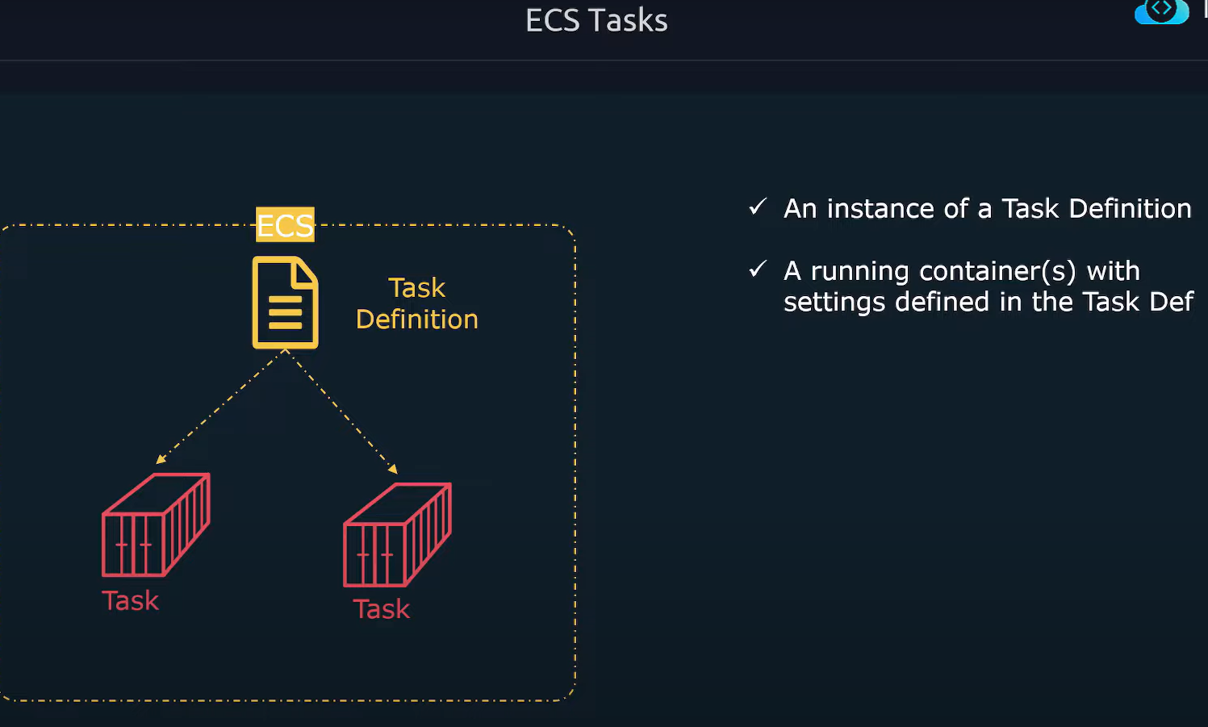

* **ECS Service**
  + A *Service* ensures that a certain no. of tasks is always running.
  + It restarts containers that have exited/crashed.
  + EC2 instance fails, the *Service* will restart task on a working EC2 instance.

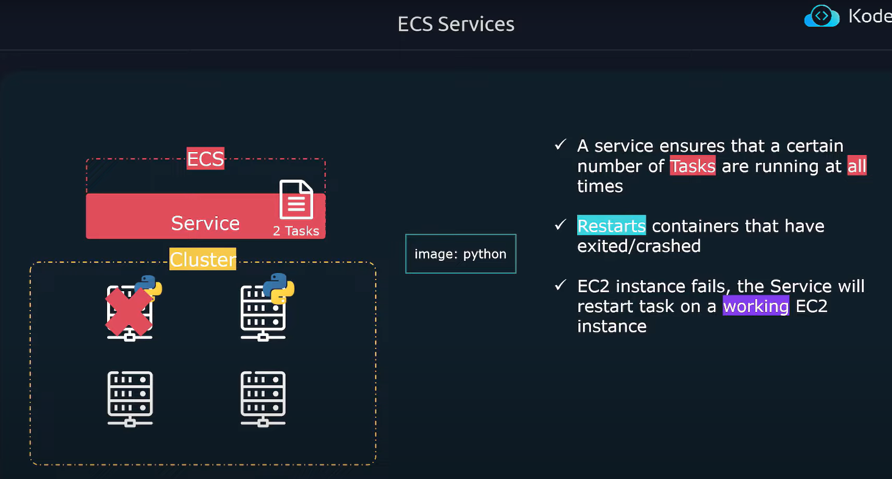

* **Load Balancers:**
  + A *Load Balancer* can be assigned to route external traffic to your service to distribute traffics evenly.

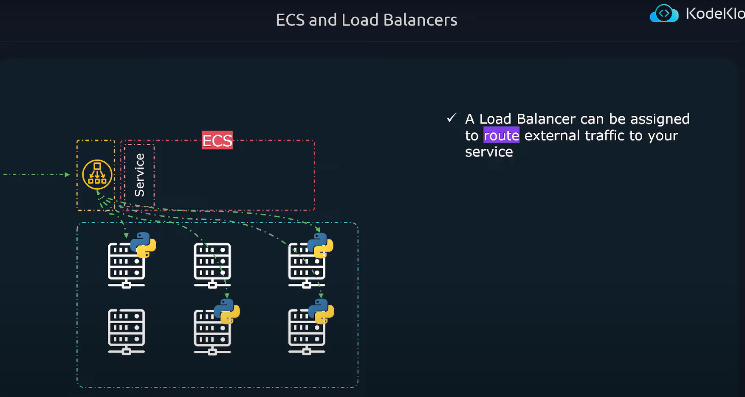

**AWS S3 (Simple Storage Service)**

* What is S3?
* S3 stands for Simple Storage Service
* It is an object storage service in amazon.
* All the files in S3 will be treated as an abstraction.

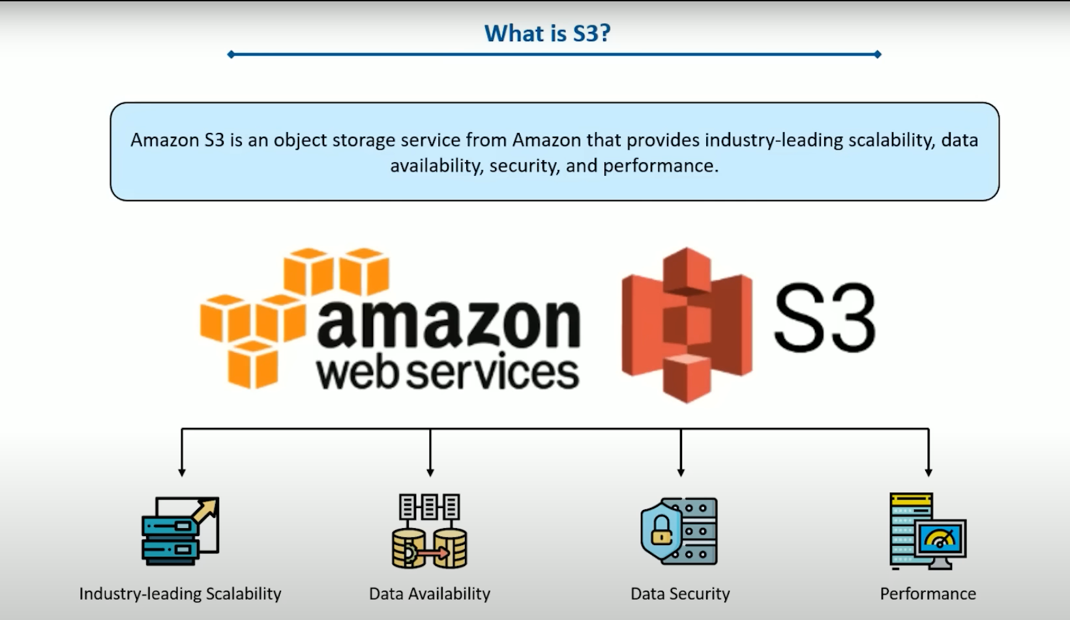

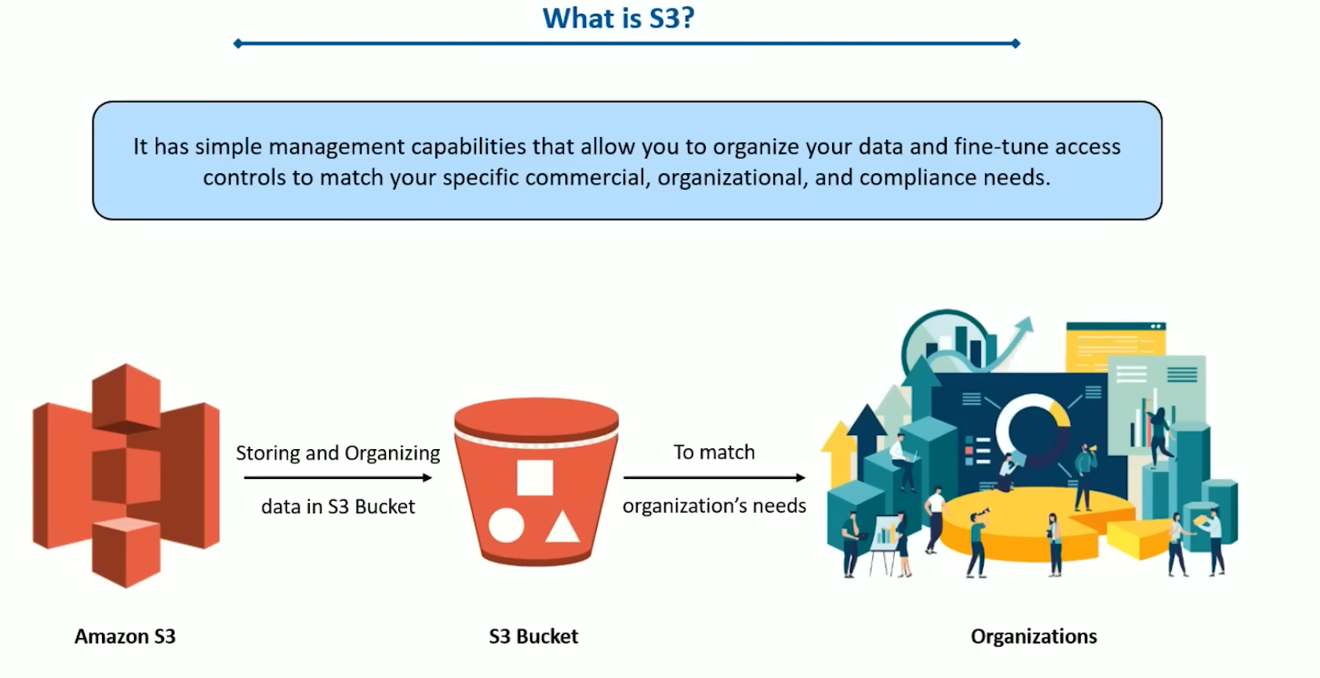

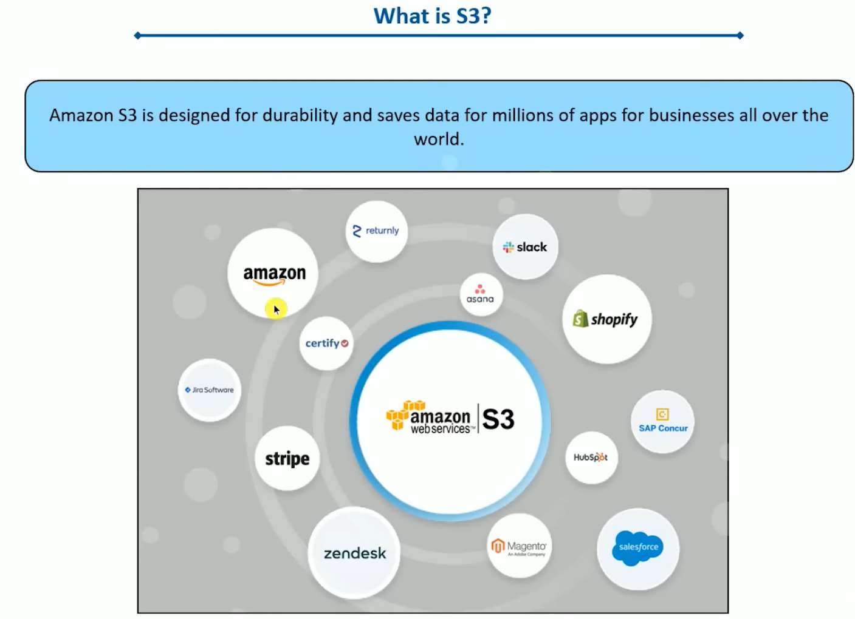

* Benefits of S3
  + S3 is the most durable service in the industry
  + It’s a serverless service
  + It has very low cost, depending on the storage classes.
  + Security, compliance, and auditing capabilities.

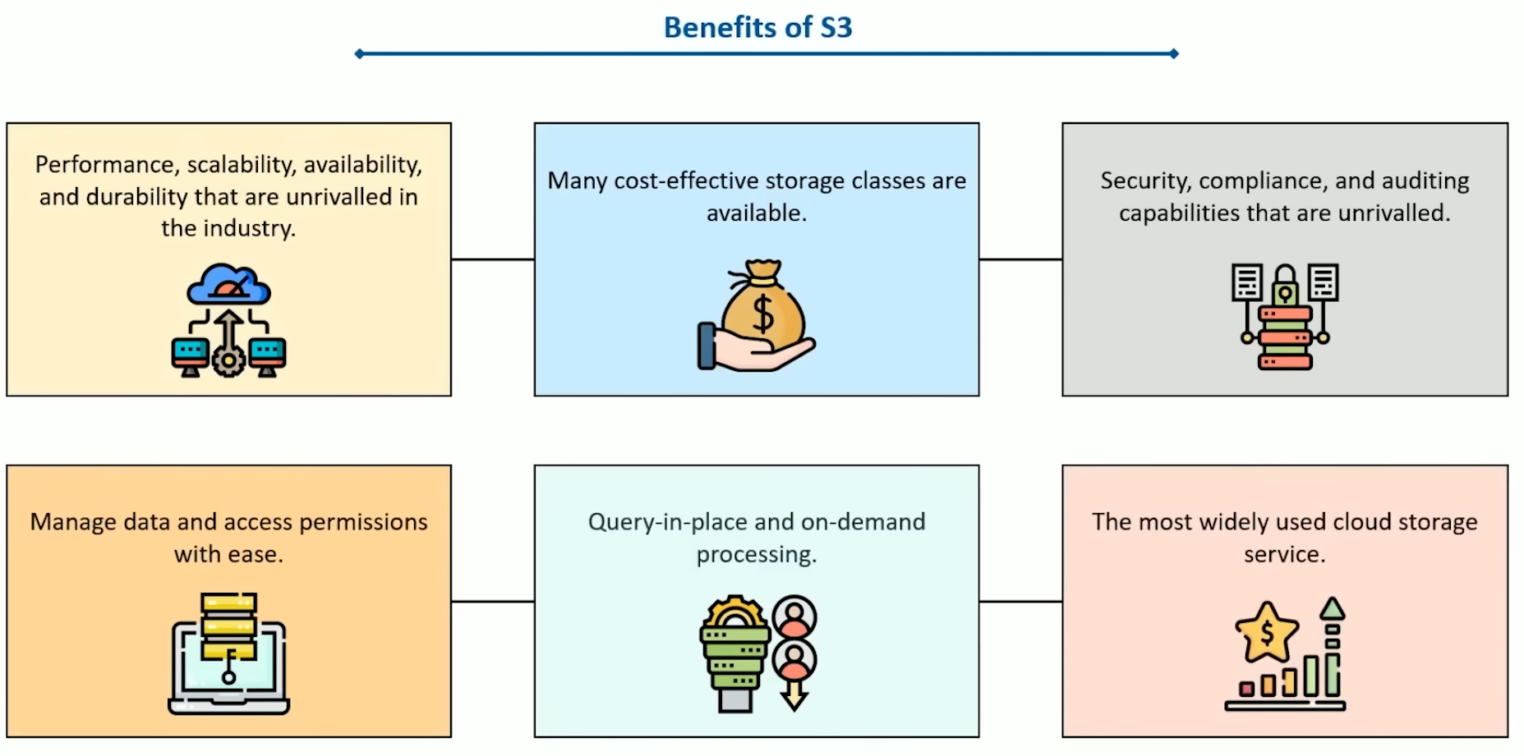

* Objects and buckets in S3

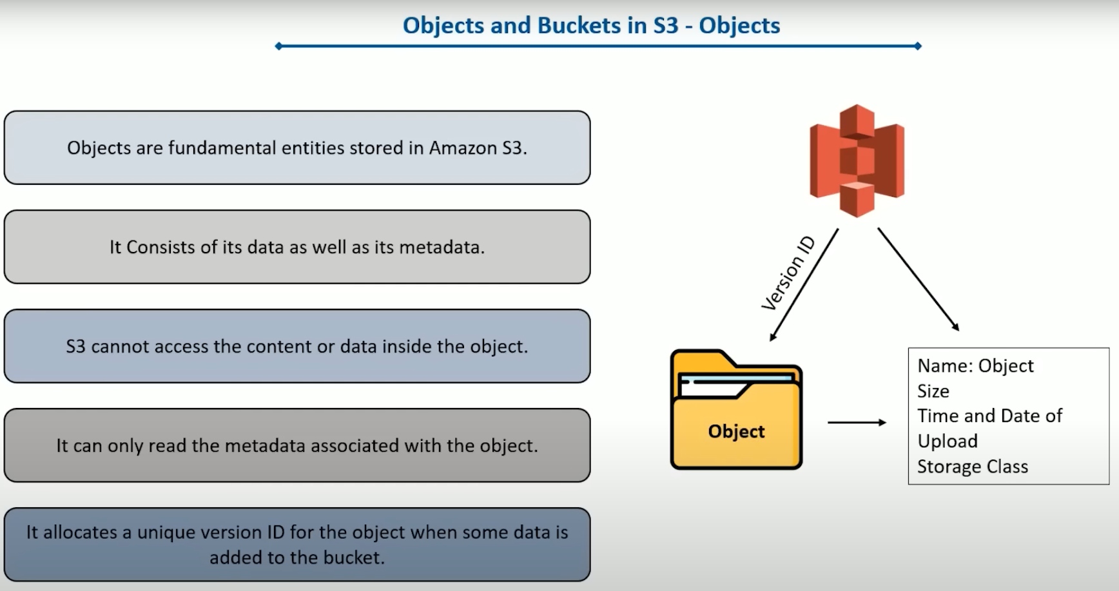

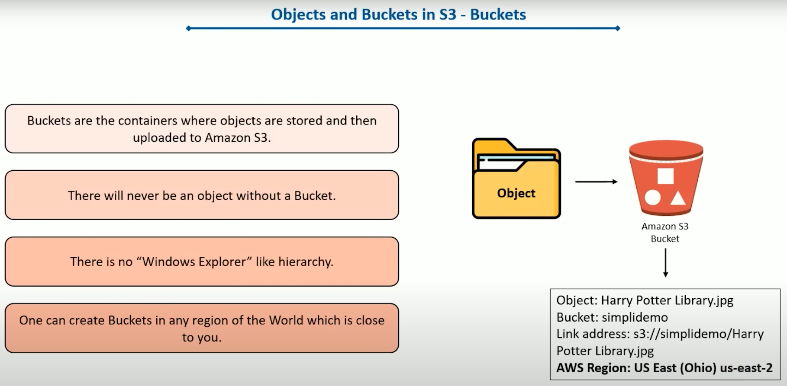

* Working of Amazon S3

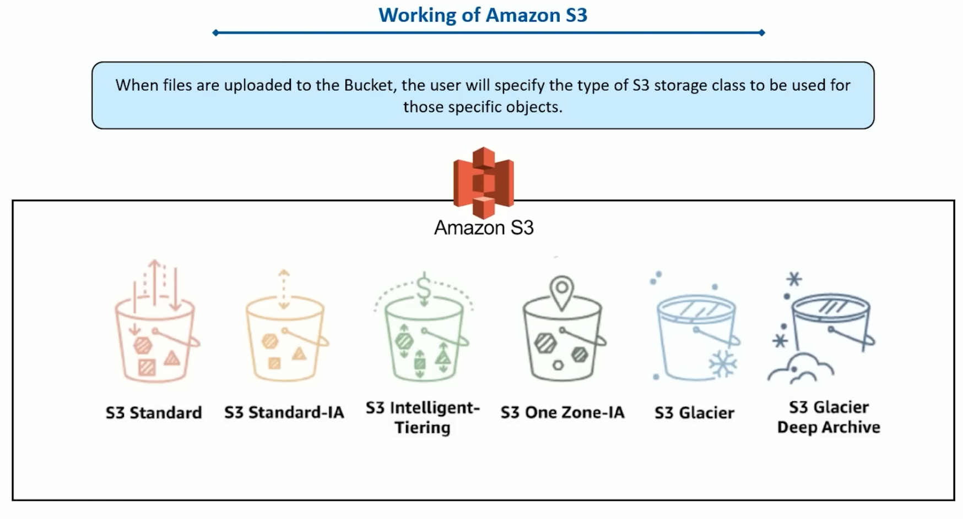

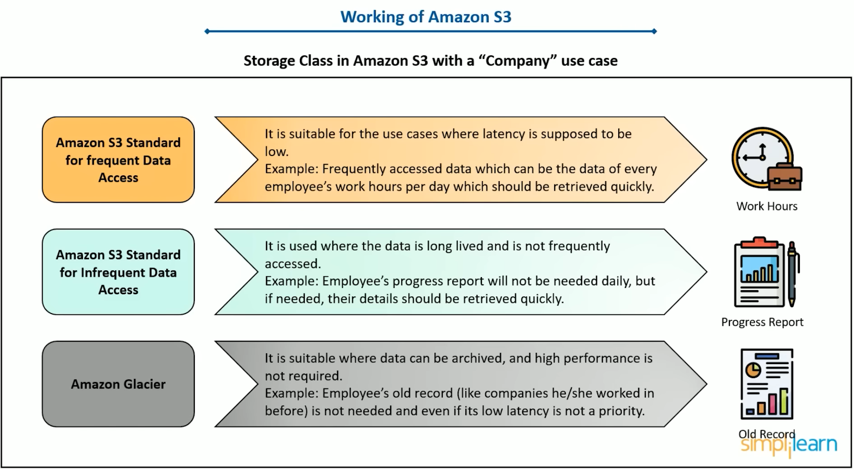

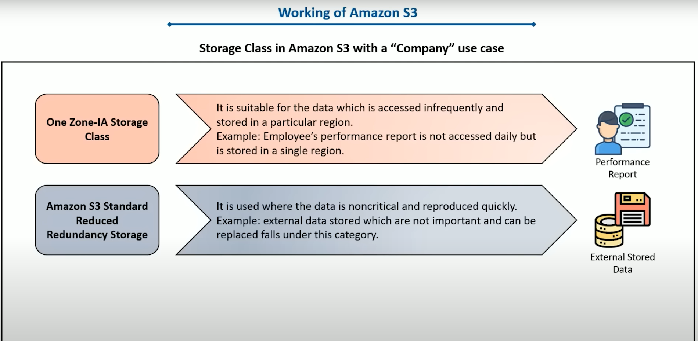

* Features of S3

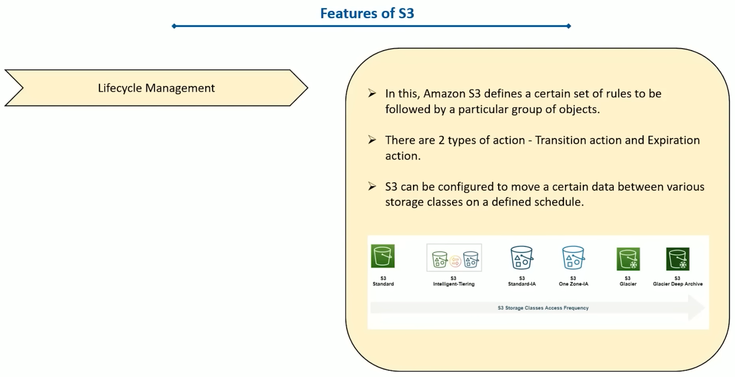

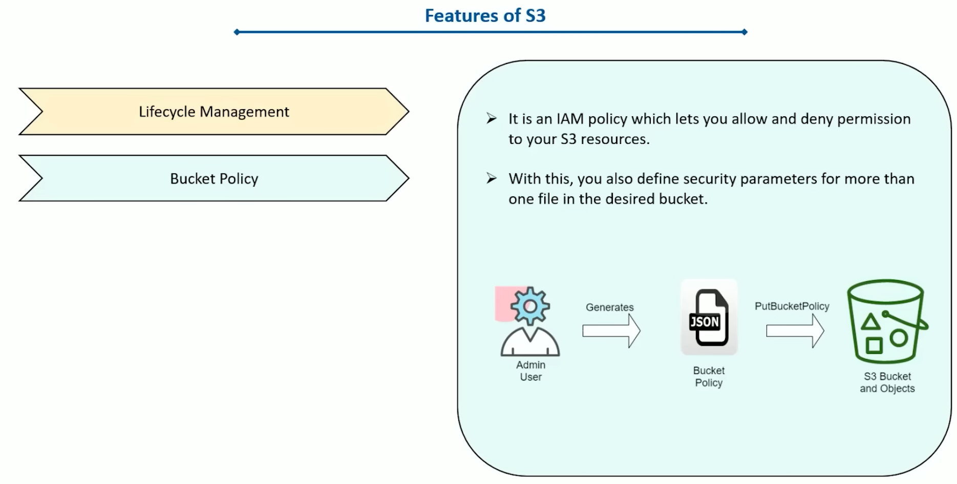

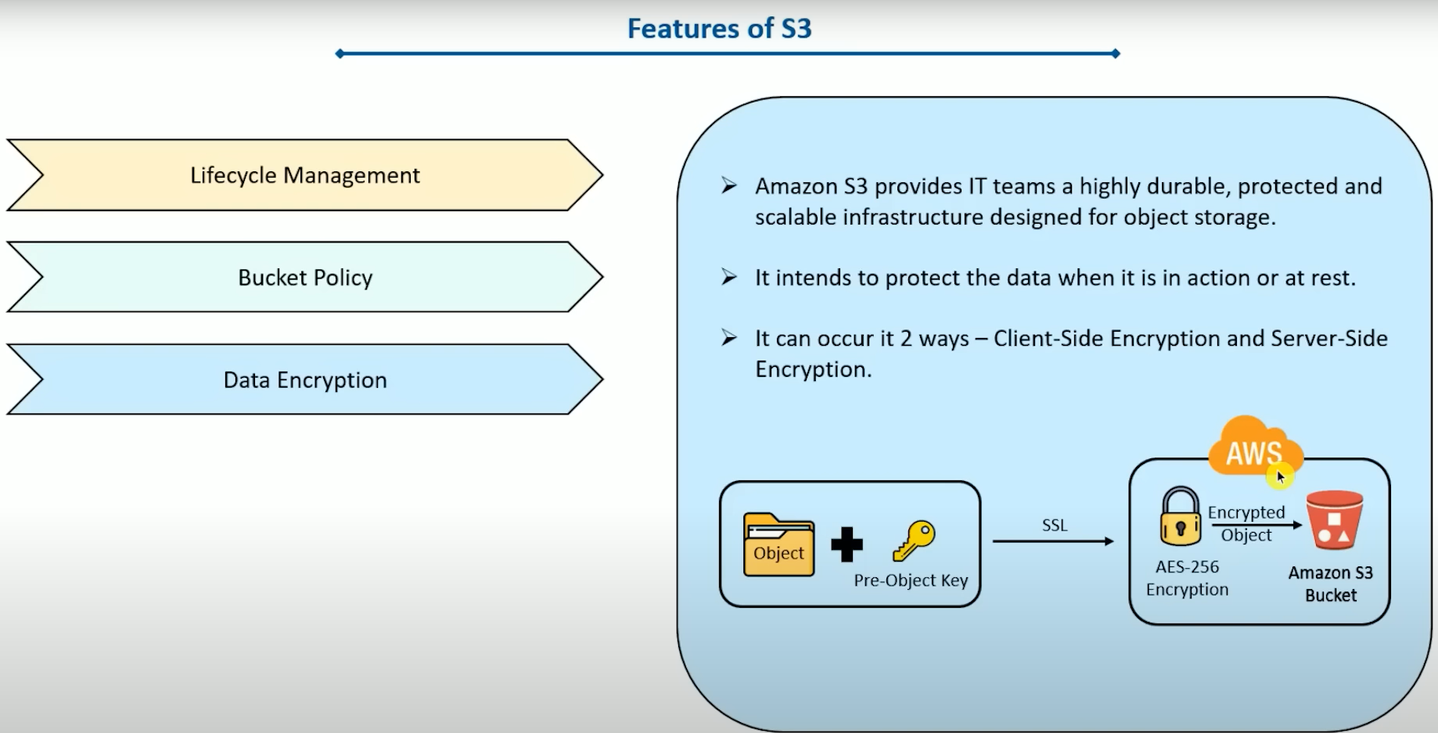

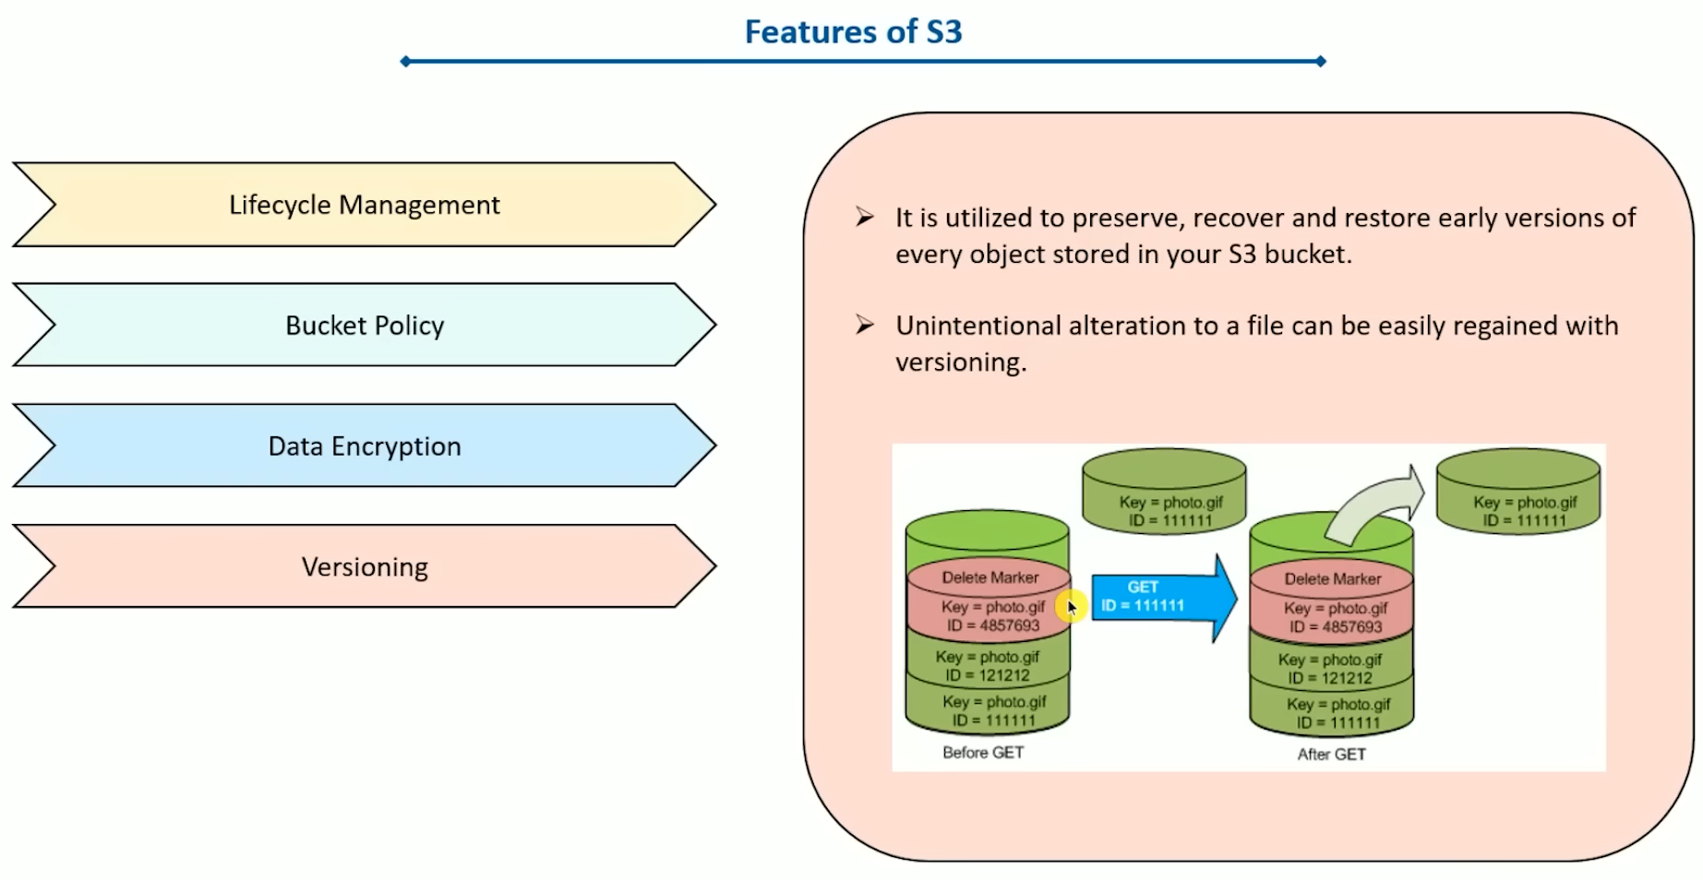

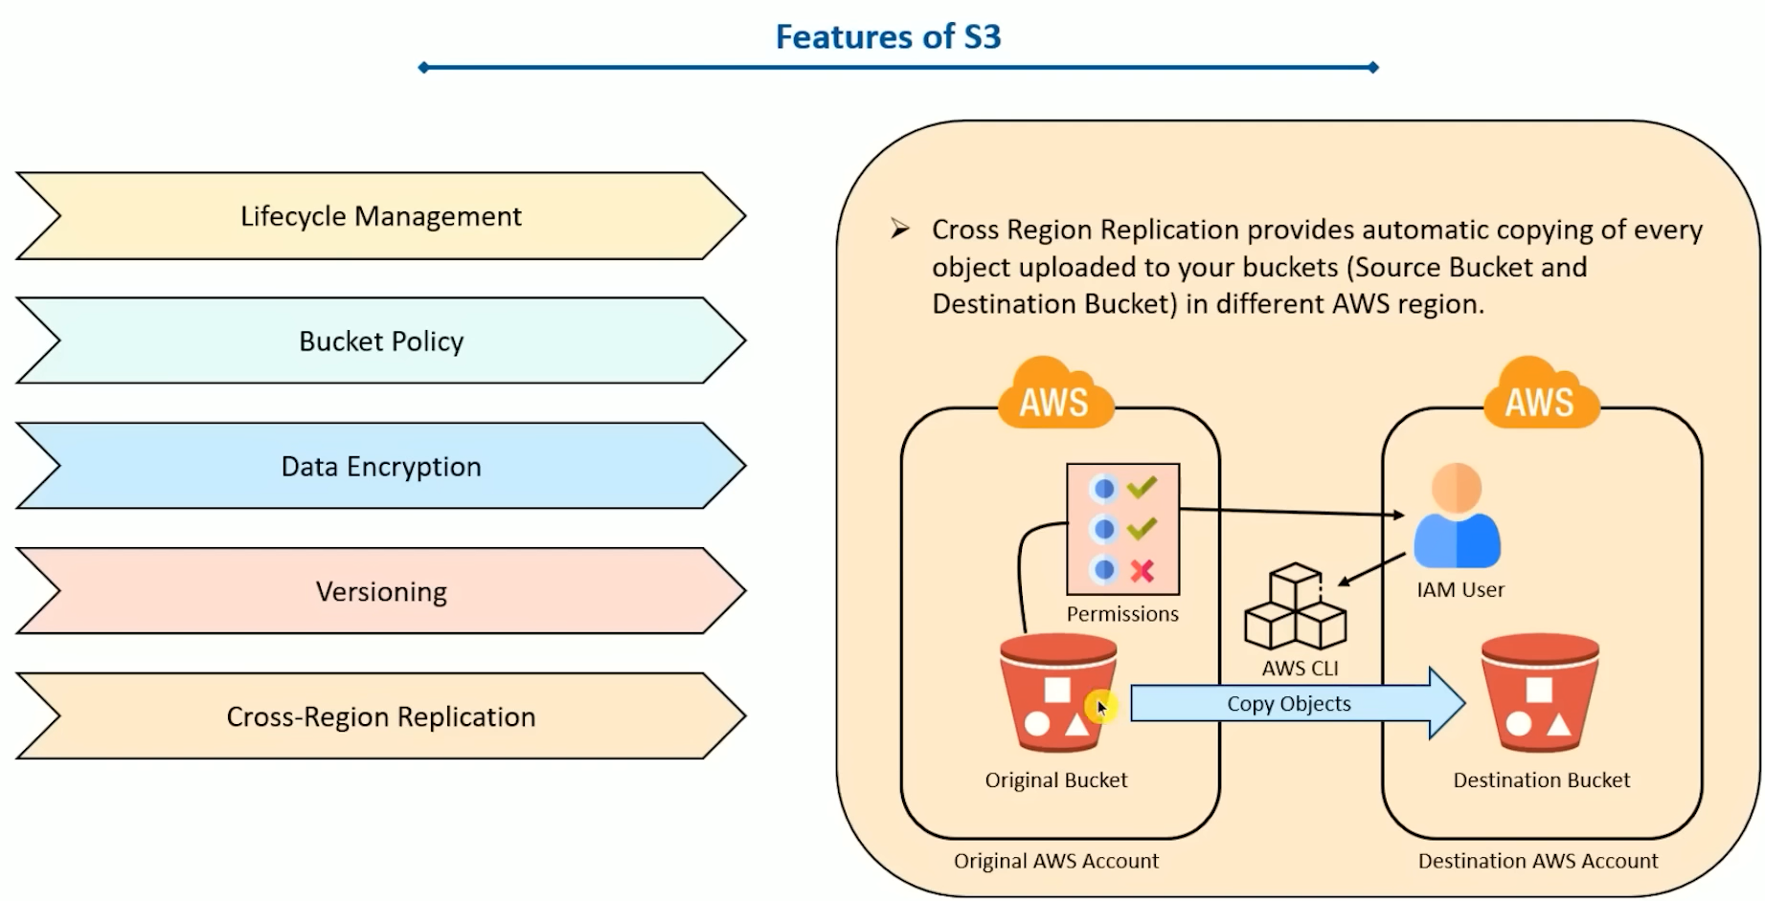

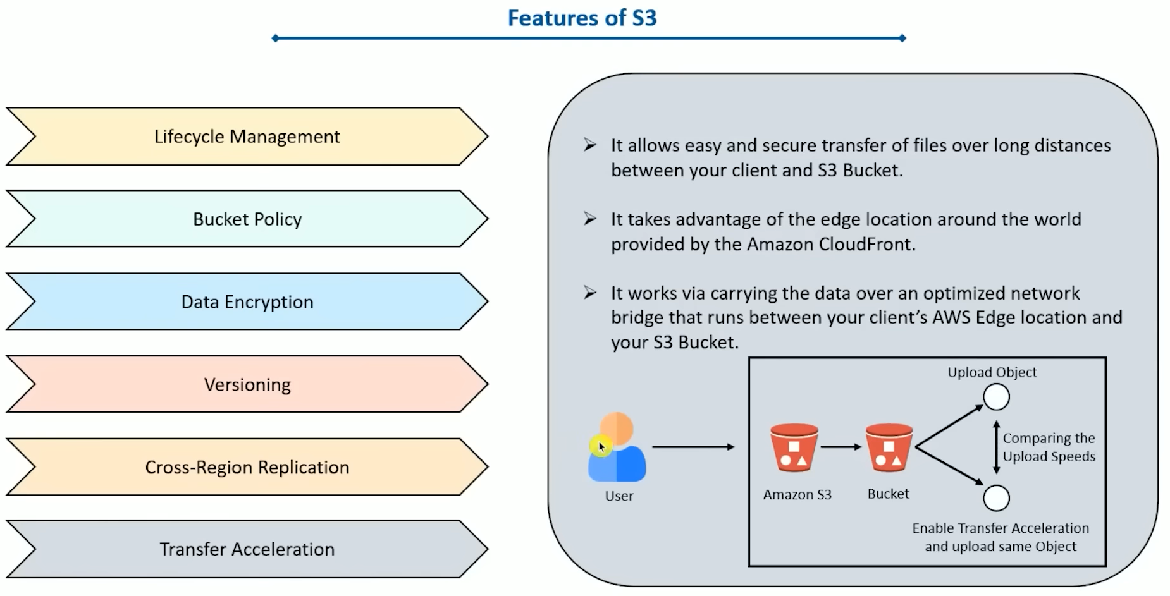

**AWS Auto-Scaling**

* What is auto-scaling & why we require it?
  + AWS auto-scaling is a service which helps the user to monitor the application & automatically adjusts the capacity to maintain steady performance.
  + In AWS auto-scaling, the server can scale itself up & down as per the requirement. This makes the project cost efficient & we won’t have to worry about the infra part.
* Benefits of AWS Auto Scaling

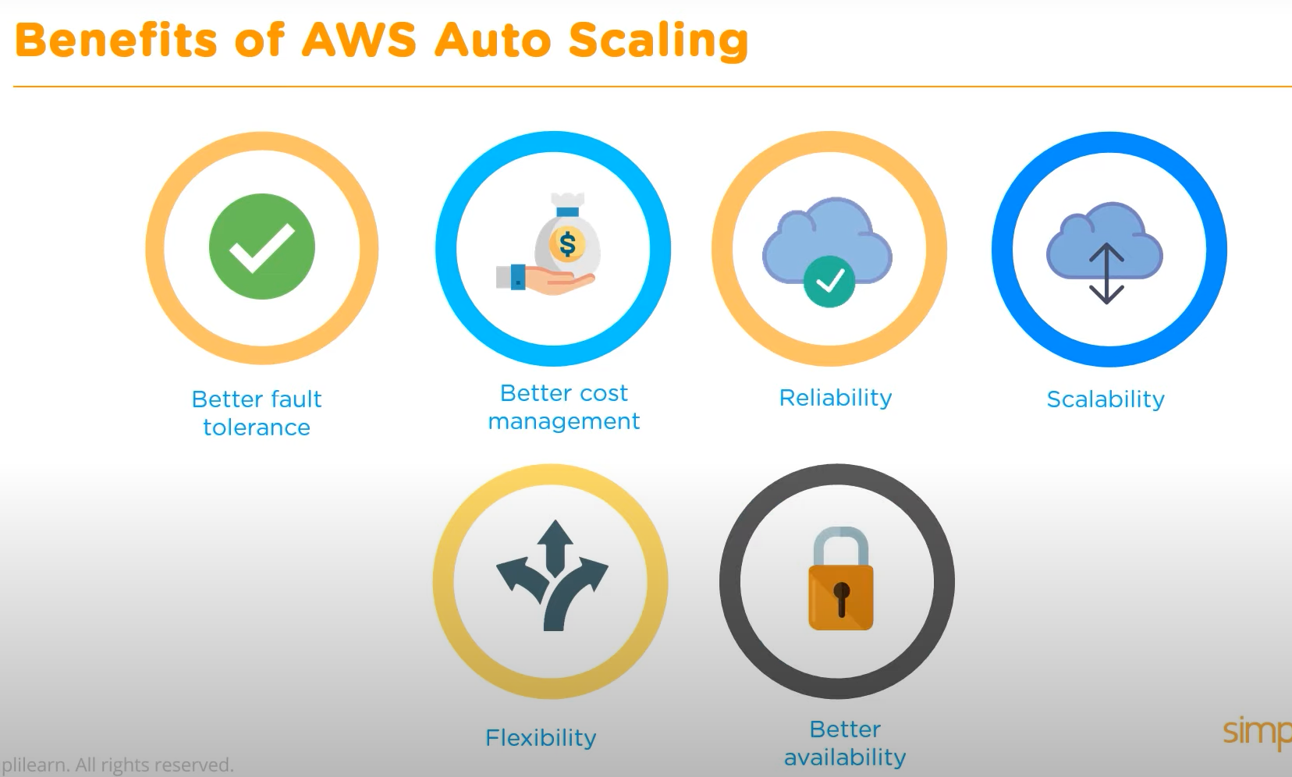

* Snapshots vs AMI

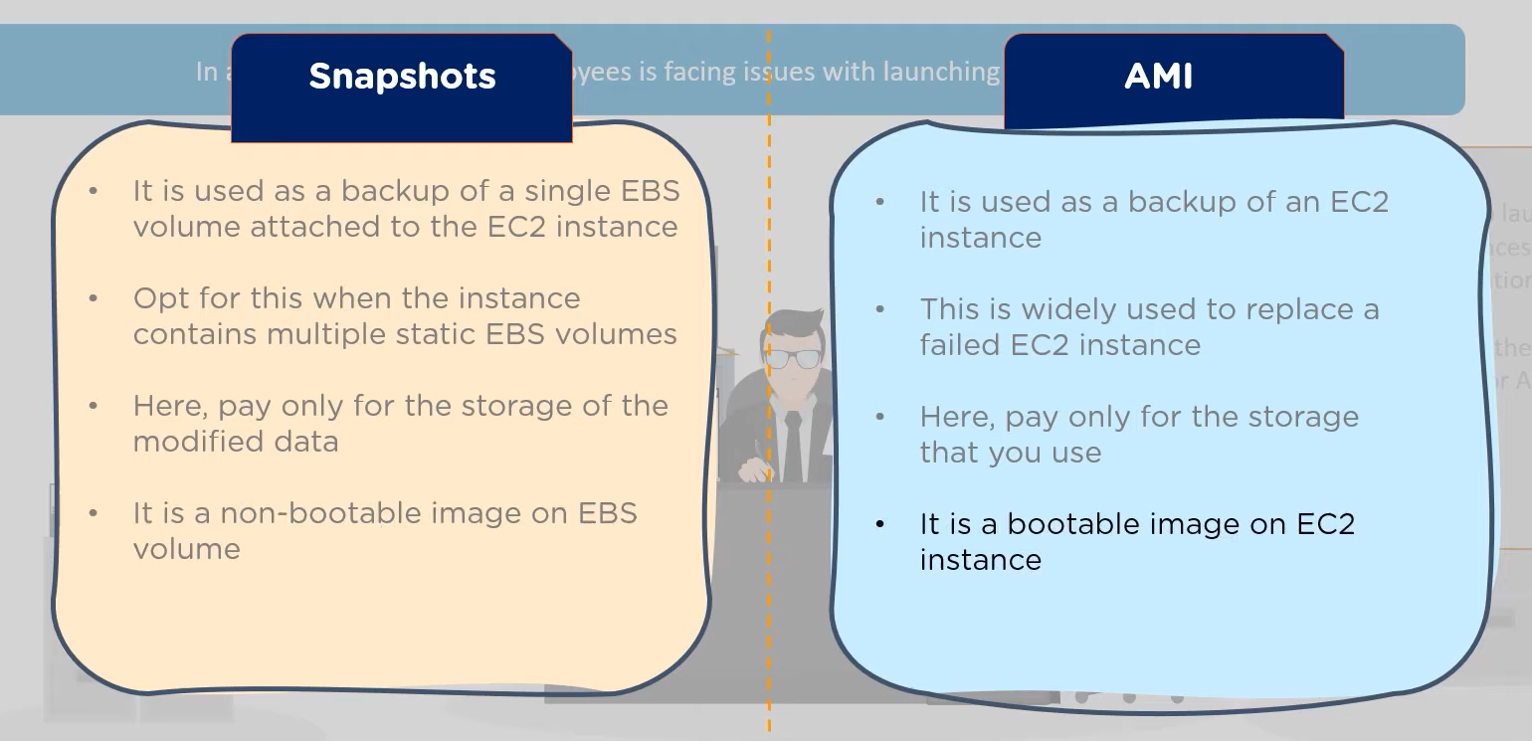

* How does AWS Auto Scaling work?

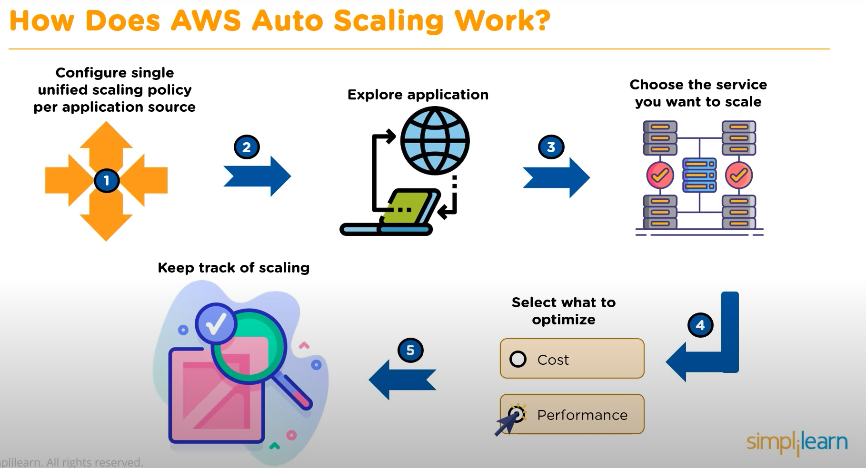

* Different scaling plans
  + Scaling strategy guides the service of AWS Auto Scaling on ow to optimize resources in an application.
  + With scaling strategy, users can create their own strategy based on the required metrics & thresholds.
  + There are 2 types of scaling:

1. Dynamic Scaling
2. Predictive Scaling
   * Dynamic Scaling

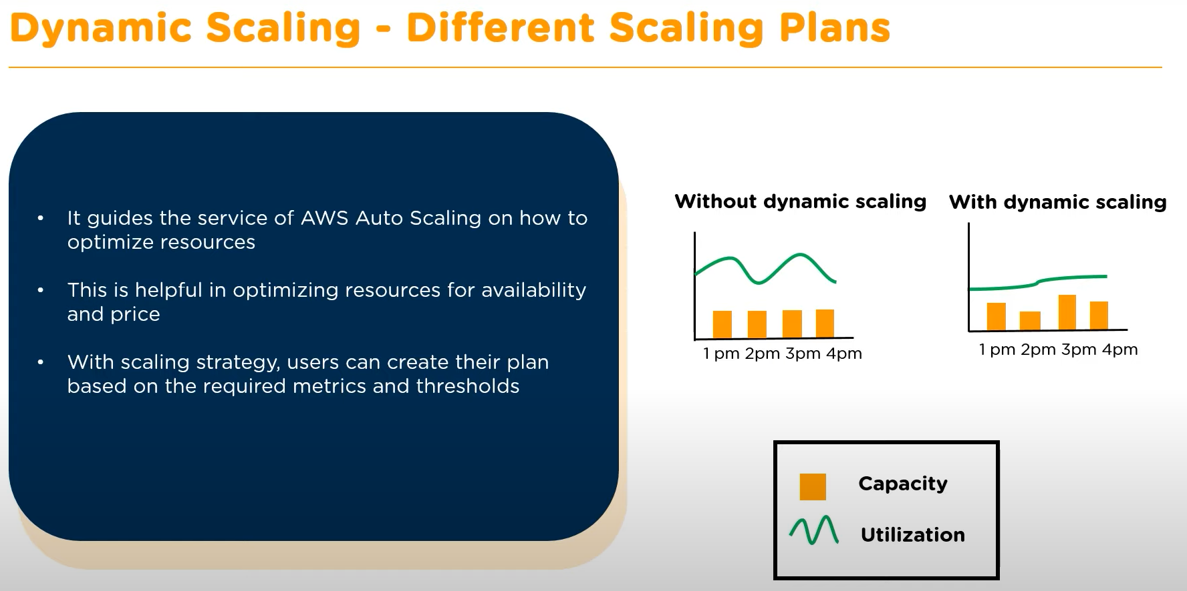

* The different metrics here could be CPU usage, Memory, Network, etc.
  + Predictive Scaling
* It is based on the prediction based on daily or weekly trends.
* It mainly used ML for analysing.

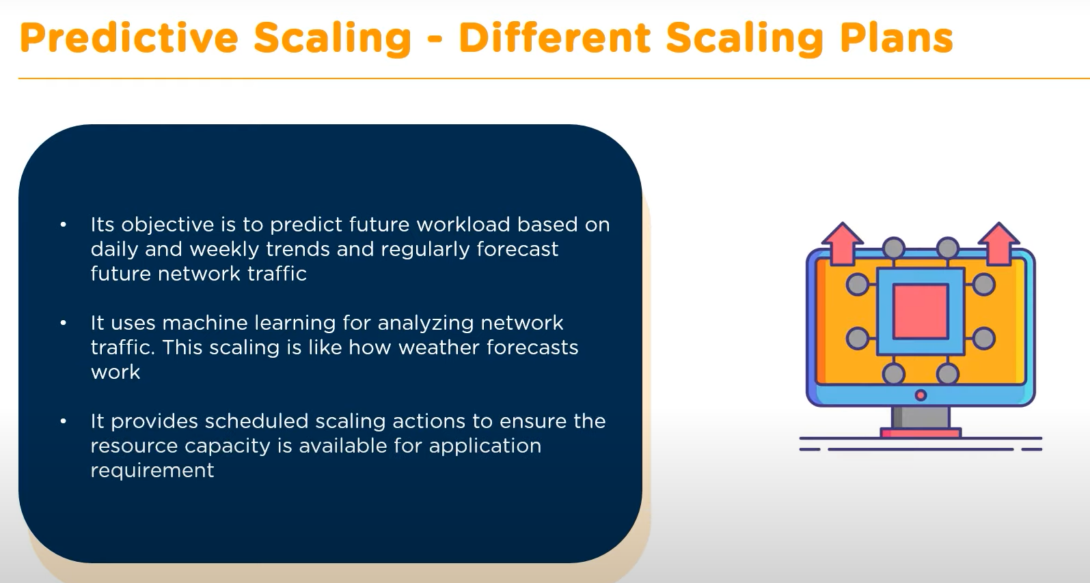

* What is a Load Balancer?

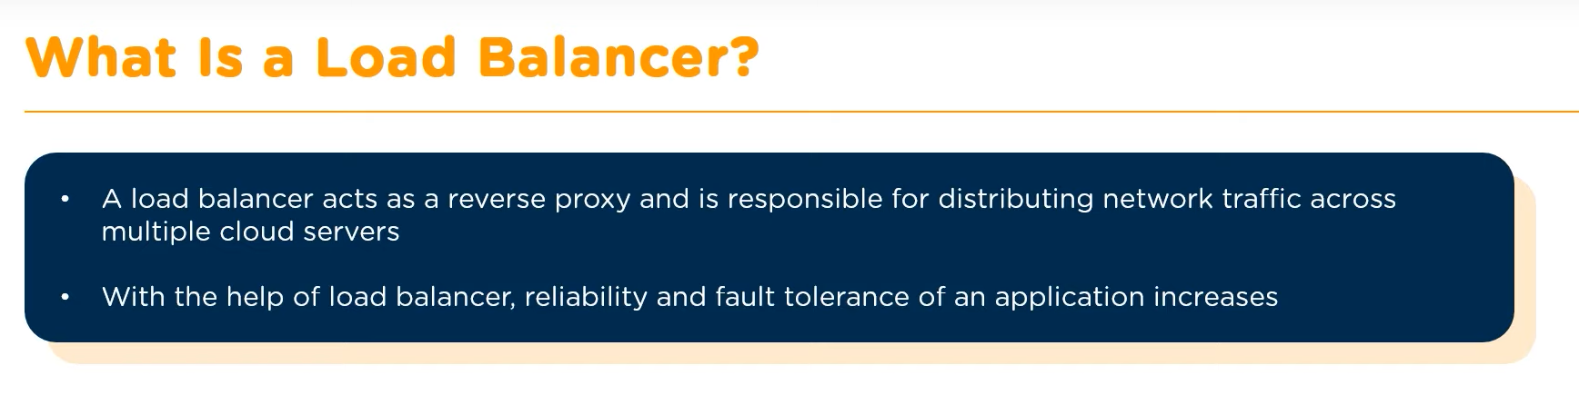

* Types of Load Balancers:
  + Classic Load Balancer
  + Application Load Balancer
  + Network Load Balancer
* Classic Load Balancer

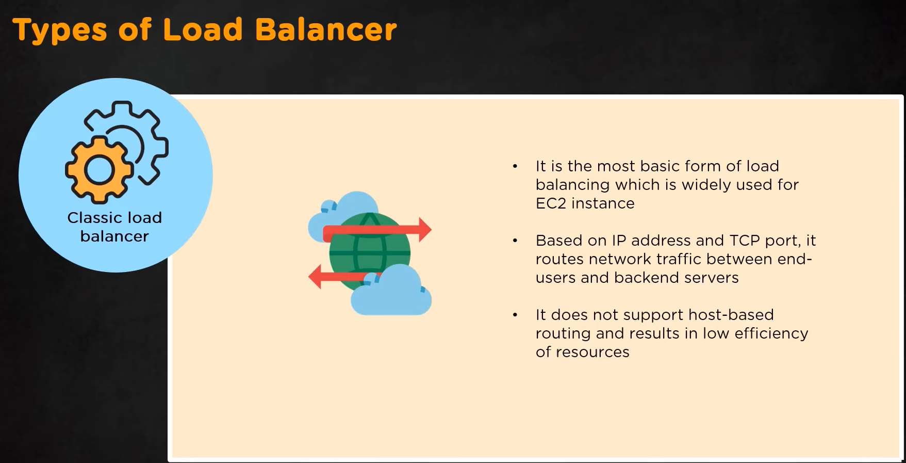

* Application Load Balancer

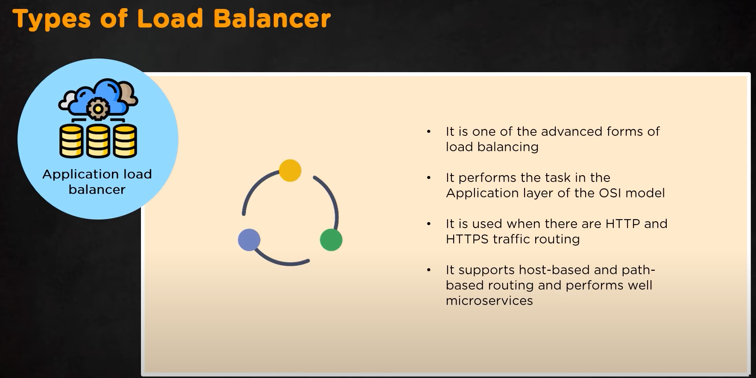

* Network Load Balancer

